What is FutureLearn? Facilitator and Guide Handbook

# FutureLearn Overview

## Background

*This document is to give Facilitators, Affiliated Guides and Guides of online courses an insight into how the FutureLearn platform works, the features available, and how online conversation can be facilitated and encouraged within a course.*

# The Platform

FutureLearn [<https://www.futurelearn.com>] is the first UK-led platform provider of Massive Open Online Courses (MOOCs) that launched to the general public as a beta platform in September 2013.

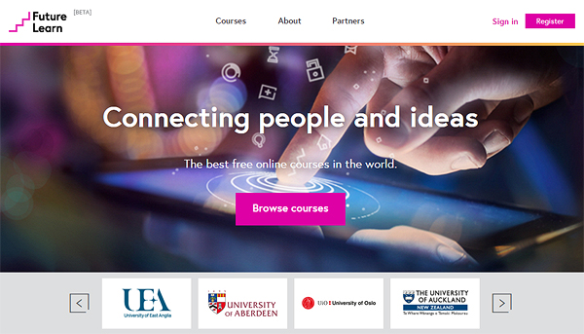

Figure FutureLearn Homepage

## What are MOOCs?

MOOCS are:

* **Massive** – uncapped numbers reading into the tens of thousands and sometimes the hundreds of thousands (though the later instances are rare)
* **Open** – registration is open to anyone that wishes to learn the course, though sometimes prerequisites are advised, they are not mandatory. The majority of the courses take advantage of the plethora of freely available learning resources, though some have links to for-fee learning material.
* **Online** – the courses are solely delivered online, either from one platform (xMOOC) or through a series of platforms (cMOOC)
* **Course** – the learning content is structured to provide learning outcomes and to quantify these through the use of tests, quizzes and assessments

MOOCs designed for FutureLearn are typically 6-8 weeks in length, and on average encompass 3-6 hours of study per week.

# Using FutureLearn

## Viewing Courses

Users can view the courses on offer by clicking **Browse courses**, where all new and upcoming courses list as default.

This course list gives a brief synopsis of the content, starting date and suggested study time required per week.

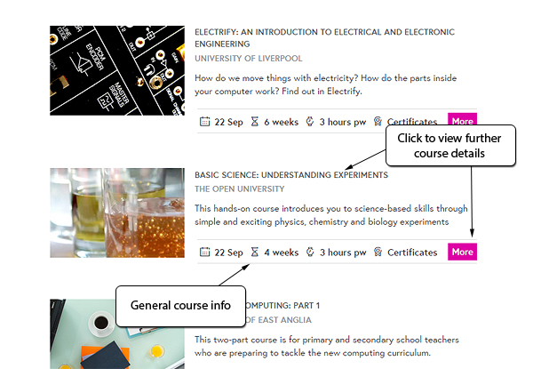

Figure Browsing courses show brief synopsis and course length/start date information

Clicking on a course enables the learner to view full details including a video trailer, summary of course content and requirements or prerequisites (if applicable).

The Lead Educator for the selected course will also be listed with a link to his/her biography.

From this page learners also have the opportunity to join the course.

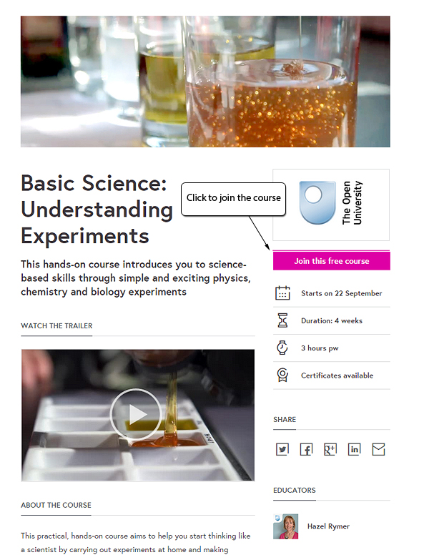

Figure Full course details page with option to join

## Registering / Signing in to FutureLearn

Before a learner can join a course they need to be registered on FutureLearn, which is achieved by clicking on the **Register** button at the top right of the screen.

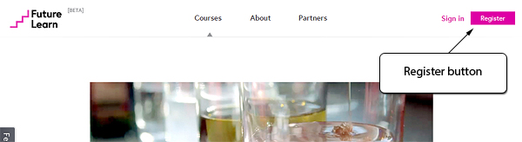

Figure Register on FutureLearn

From here, the learner is required to fill in a few simple details, agree to the FutureLearn terms and code of conduct, and then access is granted to enrol for courses.

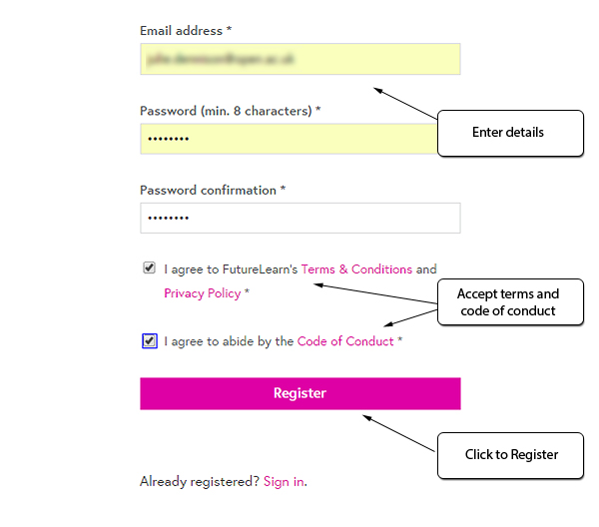

Figure Filling in registration details

Learners can join a FutureLearn course at any time throughout its presentation – even if it has already started.

Once a course has been joined, the learner will receive a confirmation email from FutureLearn giving further details about the course start date (if it hasn’t already started). Learners will also receive weekly emails from FutureLearn for the duration of the course that outline upcoming content and other relevant information.

## Profiles

It is advised that learners complete a profile where information can be added about personal interests, enrolled courses, social activity and a photograph.

Profiles are accessed by clicking on the icon at the top right of the screen, which displays a slide-out list of different options.

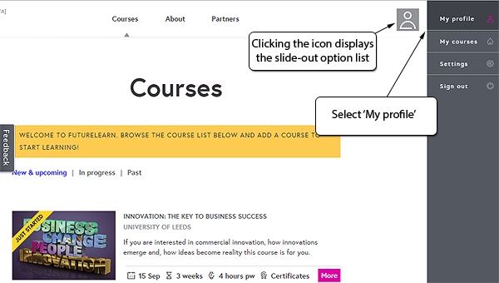

Figure Selecting ‘My profile’ from the slide-out menu options

Once registered, learners can now click on the **Join this free course** button on the course details page.

# The presentation of a course within the FutureLearn platform

Since FutureLearn launched, The Open University has presented many MOOCs including *Introduction to Ecosystems****,*** *Start Writing Fiction*, and *Forensic Psychology*.

Once a learner has joined a course they can click on the **Go to course** button from within the course details page, by clicking on **My courses** from the slide-out options panel, or from their home page (which will list all the courses the learner has joined when they log into FutureLearn).

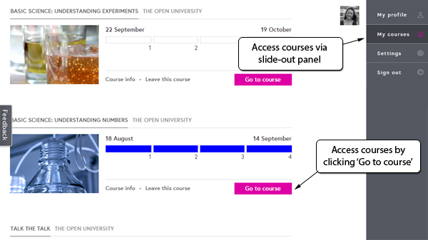

Figure Ways of accessing enrolled courses

Entering the course shows a breakdown of the various different study weeks contained within the course and once the course has started, shows the running position of the course week by week, highlighted in blue.

Within each week the course is broken down further into individual steps, of which should be worked through in order. Step activities include reading articles, watching videos, partaking in discussions, undertaking quizzes (not part of the final assessment), tests (part of the final assessment) or assignments (part of the final assessment).

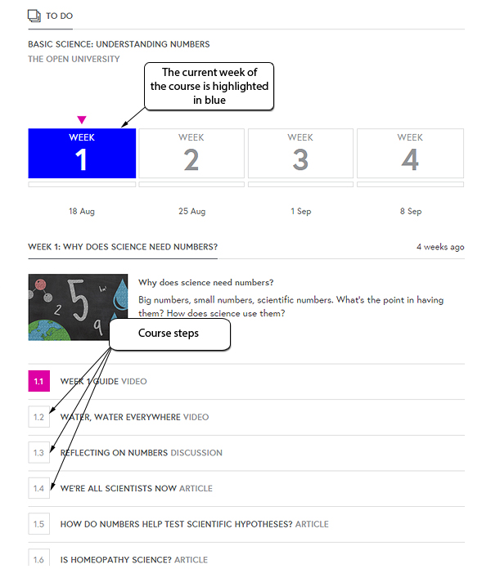

Figure Structure of a course showing the weeks in running order and the selected weeks’ steps

Clicking on an individual step gives full information on what the learner is required to do and can also include additional activities such as links to external sites, or downloading embedded PDF files for further reading.

Learners can also add comments after each step, with this function being imperative for the discussion activities.

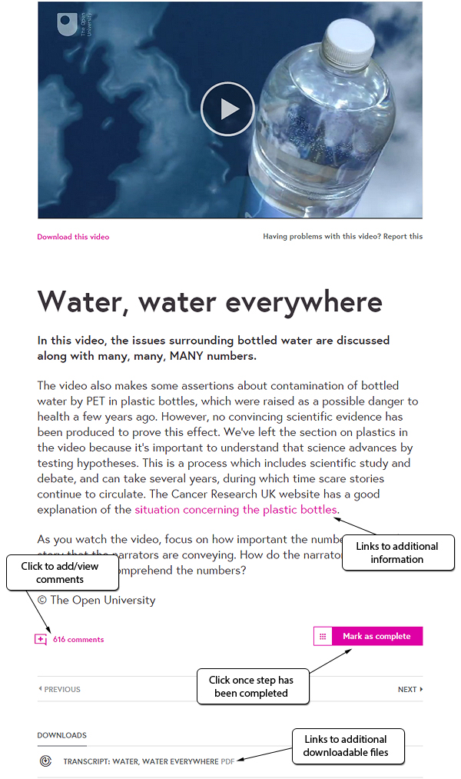

Figure Example of a step within a FutureLearn course

The ability to mark steps as complete not only allows the learner to take a break from their course, but also to quickly recognise their progression through the course. Completed steps show as blue on the weekly breakdown, pink highlighted step numbers depict the place as to where the learner has reached, and white signifies that the step has not yet been visited.

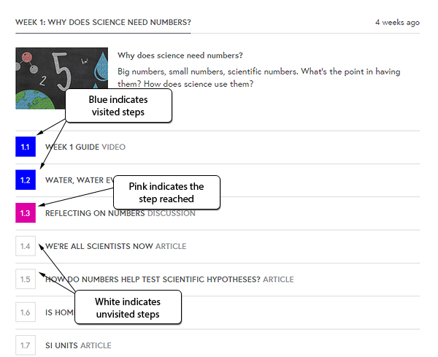

Figure Colour coded steps show the learner at a glance where they are up to in each week of the course

Throughout the course there may be opportunities for the learners to undertake different levels of assessment quizzes, tests or assignments, where the learners are presented with each question separately, and given options to select and submit. On submission of each answer the platform will inform the learner if they are correct or incorrect.

If the learner is incorrect, they will be given two further opportunities to attempt the question with helpful pointers to parts of the course that the question relates to. With three points available for each question, a point is deducted for each incorrect attempt.

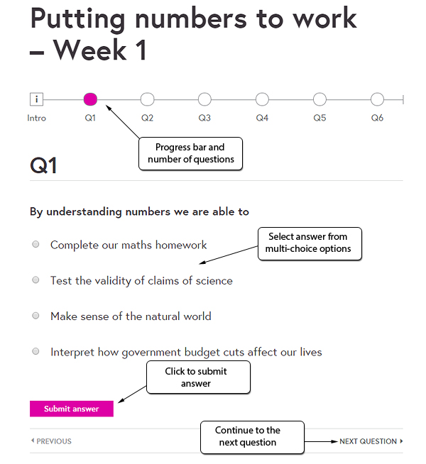

Figure Selecting and answering test questions

After the completion of any final assessment tests at the end of a course, the learner is presented with a summary screen and score.

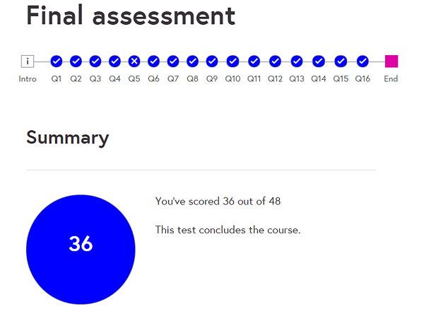

Figure Example of a final assessment summary screen

## Certification

All courses on FutureLearn give the learner the option of purchasing a Statement of Participation certificate, and to qualify, the learner must mark at least 50% of all course steps as complete plus attempt all available test questions.

The option to order a certificate and to check progress on the course can be accessed during the final week of the presentation.

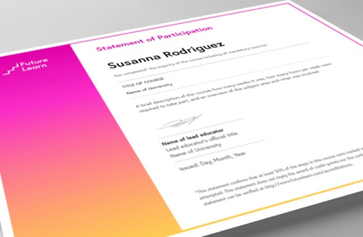

Figure Example of a Statement of Participation

These printed Statements of Participation provide a record of the learner’s engagement in their chosen course, and are a great way to show evidence of formal or informal Continuing Professional Development, commitment to a career or interest in a particular subject.

## Feedback or technical support

If at any point within the course a learner wishes to give feedback or report a problem with something on one of the courses, then they can select the **Feedback** button that is on every page of FutureLearn.

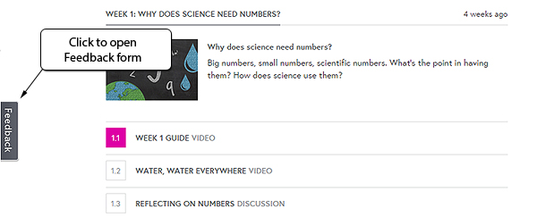

Figure Accessing the Feedback form

The Feedback form is in two parts. The left hand side of the form gives the learner options of searching the knowledge base, or looking through frequently asked questions. Ideas that have been submitted by other learners can also be browsed which also display the status as to whether the item is underway, or planned.

On the right hand side of the feedback form the learner can submit their idea to FutureLearn or by selecting **Send a message** can send a technical query or problem within the platform itself to the team.

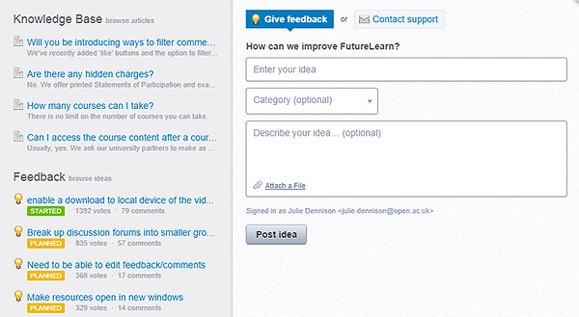

Figure FutureLearn feedback form

# Facilitating and Guiding on a FutureLearn Course

Full details of roles for facilitators and guides are given in the online courses ‘*Online Learning:Facilitators*’, ‘*Online Learning: Affiliated Guides*’ and ‘*Online Learning: Guides*’ taken in preparation for these moderator roles, but part of the role will be to moderate and join in with online conversations.

Each step in every week of a course offers the opportunity for learners to add comments or pose questions, and in discussion activities especially, there can be many comments posted.

At the end of each step the amount of comments received will be shown, and clicking on this will expand the selection to display the posts.

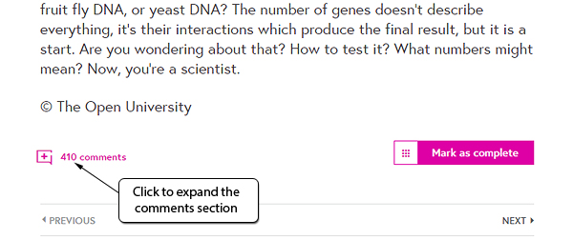

Figure Expanding comments within a course step

Tests, quizzes, assignments and assessments do not have the option to post comments.

The ‘**comments’** or ‘**Join the discussion’** link at the end of each step will state how many postings have been received. Steps with a **comments** link will expand to show the learners’ posts, whereas discussion activities will automatically list the posts at the end of the page without the need to expand the section.

Although, as a facilitator or guide you will need to be generally vigilant on all comments and postings, it can be very useful to filter the list, as the platform displays all comments by default. Filters can be selected at the top of the comments section.

As default the platform lists everyone’s comments.

There are several helpful options available to filter posts:

* **Everyone** – lists all posts
* **Following** – lists posts from learners you have selected to follow
* **Most liked** – lists posts that have had the **Like** link clicked. This filter lists these posts in order of the most popular first
* **My comments** – lists contributions you have added within a specific section. This filter can be especially useful if you need to check back to see what you have written in respect to specific posts

To select a filter, click on the one of the links at the top of the comments/discussion section for a step, and the results will be displayed underneath.

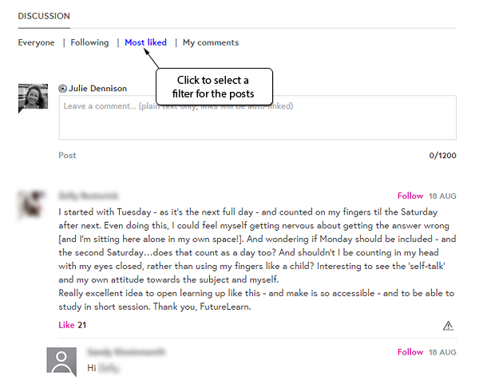

Figure Selecting a filter for posts

Filtering these comments to **Most liked** is a good initial starting point.

## Adding and replying to posts

As covered in the Facilitator or Guide Training courses, you can leave a new comment by typing directly into the box at the top of the comments/discussion section.

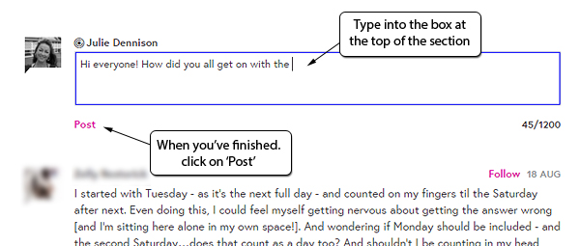

Figure Adding a new post

Specific posts can be directly responded to by selecting the **Reply** link underneath the relevant post before typing in your comment.

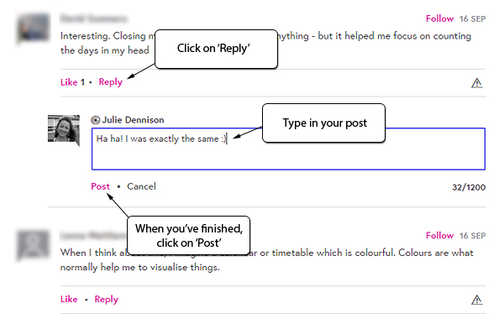

Figure Replying to individual posts

In instances where you feel a comment isn’t suitable (guidance for this is covered within the Facilitator and Guide Training courses), use the **Report** icon underneath the relevant comment to flag this up.

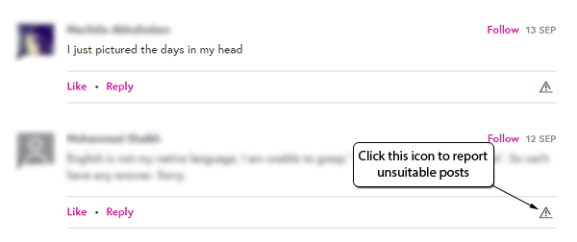

Figure Reporting unsuitable posts

## More about FutureLearn

If you wish to find out more about FutureLearn and its development, further information can be found in the links below:

About FutureLearn [ <https://www.futurelearn.com/about> ]

How FutureLearn works [ <https://www.futurelearn.com/about/how-it-works> ]

FutureLearn’s partners [ <https://www.futurelearn.com/partners> ]

Terms and conditions of FutureLearn [ <http://about.futurelearn.com/terms> ]

FutureLearn’s blog [ <http://about.futurelearn.com/blog> ]